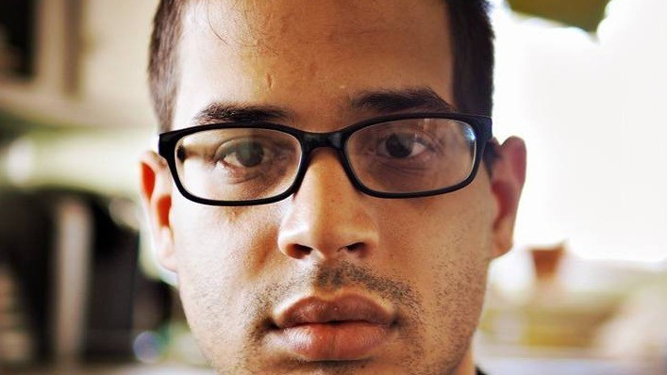

The Second Try
by Chris Twist
by Christopher Twist
I can’t say enough incredible things about QVegas. I couldn’t try to work if I didn’t start writing for QVegas. I finally felt like I was an author again. I wasn’t just a man who had a brain injury.
It made me think about more than my problems and it gave me the strength to tell people that I am a columnist again. It’s still weird to think about the fact that two years ago I could only say “fuck” and “love,” but now I can write all of this without anybody to help me. It makes me feel like I’m going to be fine in the end. I really needed QVegas to tell me that I am able to do these things that I used to do so very well. I was finally going back to something that was such a big part of my mind and whatever souls are. QVegas will always mean a lot to me because I am now a creator again; and nobody can change that. This was something that I needed, and QVegas was there to help me when I needed it the most.
Now, I use exercise more than anything. It works both my body and my mind in ways that only training can do. Monday-through-Saturday, I do push-ups, squats, abs, and the treadmill to burn about 500 calories. It helps me to like myself, to love how I look, and mostly it helps my intellect, my ability to multitask. It helps my consciousness to work with words, sentences, paragraphs, and this article, all of my essays. Anybody who thinks that working out only helps the figure and doesn’t help the awareness-of-your-judgement is very, very wrong. Exercise increases circulation. This helps heal my brain. Exercise also helps your brain by cleaning your mind. I think that all of you who are reading this article right now should have sessions every day, even if just little portions of body work. Doing little bits of active-work every day will still help your shape and your talent, whatever that talent might be. It will help you in more ways than you would think. Using exercise has made by brain stronger and ready for more, like working, a part of my life that I miss. Without movement, I wouldn’t be this excellent.
I also read and write every day. I either study books or compose music or prose every day and my ability to do both of these things is getting better all the time. I feel like I’m ready to work as an author again. I can see why others thought that I could only read easy children books and not harder adult books; but that is not true at all. One of the first books that I read was The Great Gatsby by F. Scott Fitzgerald. This is definitely an adult book, one of the books that I read when I was in school for my B.A. in English. I was so happy that I could finally read the kind of books that I used to love, and that I still love those books. Another book that I read was called “Digital Marketing Practice Guide for SMBs: SEO, SEM, and SMM Practice Guide” by Venakataramana Rolla. This book is all about working with the world of websites and search-sites like Google, Yahoo, or Bing. I’m still writing advertisements and shows. Now, I have made seven advertisements and two episodes of shows that are popular shows. I used to be an SEO writer in Las Vegas for three years, and I thought, now that I can write again, that working as an SEO writer would be great for me, but I wanted to read a book about SEOs to make sure that I really have the ideas and the facts about how SEO works and help shops around the world. I’m also writing all the time, like right now. Right now, I’m writing an article about everything that I do and want to do. Every time that I use words in sentences and paragraphs, it helps my brain and helps me to go back to the person that I used to be. I am always yearning for more, more words, sentences, paragraphs, and chapters.
I started a class for beginning photography on October 24th. I have done this class before, but I don’t know how much I will remember, so I wanted to go back to the. It would be incredible if I could, eventually, become a photographer for work again. I have a camera. I’m looking forward to this.
I was a writer for many companies in the last ten years. My favorite work was with Edelman, one of the world’s biggest advertising company. My clients included: Dixie, Quilted Northern, Brawny, Angel Soft, Papa John’s, Sandvik Mining, Nestle, Juice Plus+, Laser Spine Institute, mBlox, Gap International, and Arby’s. I was a writer and a photographer. I was also a writer, content, and communications coordinator for Wonder Soil. I was an interviewer for NV Business Services/Mitchanne LLC where I wrote business plans. I even wrote a novel when I was only twenty-one. Now, I try every day to get better with words and ideas.
This was how I was going to start working again as a writer, as an SEO writer. I think that this work would be marvelous for my aphasia because I can use the thesaurus all the time and use new words in my writing. Like how I just used “marvelous” in this paragraph. I didn’t know about “marvelous,” but I did know about “amazing.” So, I used the thesaurus to look at more words that were like “amazing.” Marvelous was a better word to use than “amazing.” If I did this all the time as a writer for SEOs, then I would always use new words and my aphasia would affect my life less and less. Companies don’t want to work with a person who has a brain injury. I’ve tried to email every group for SEOs in Las Vegas, and nobody wants to work with me. I don’t think that this is right at all. Just because I have a brain injury doesn’t mean that I’m going to be happy with the little bit of money that I get each month for my disability. Actually, I hate my disability money. I would rather work then get a little bit of money each month, and I’m ready to work. I want to work more than anything in my life. Working was such a big part of me. Working all the time would get my mind away from myself and that would be very good for me.
If you have friends or family who have a brain injury, don’t just think about them as a brain injury survivor. There is so much more about us that you need to know and care about. It’s easy to think that these people will never be anything more than their brain injury, but this is wrong and it makes us feel like we are already dead in a way. The goals that I have make me who I am, not my brain injury. Every day, I try to be active and able to do new things, because I will never feel like I’m done learning and making new materials so that I can be better than I used to be.

