QLife - Magazine

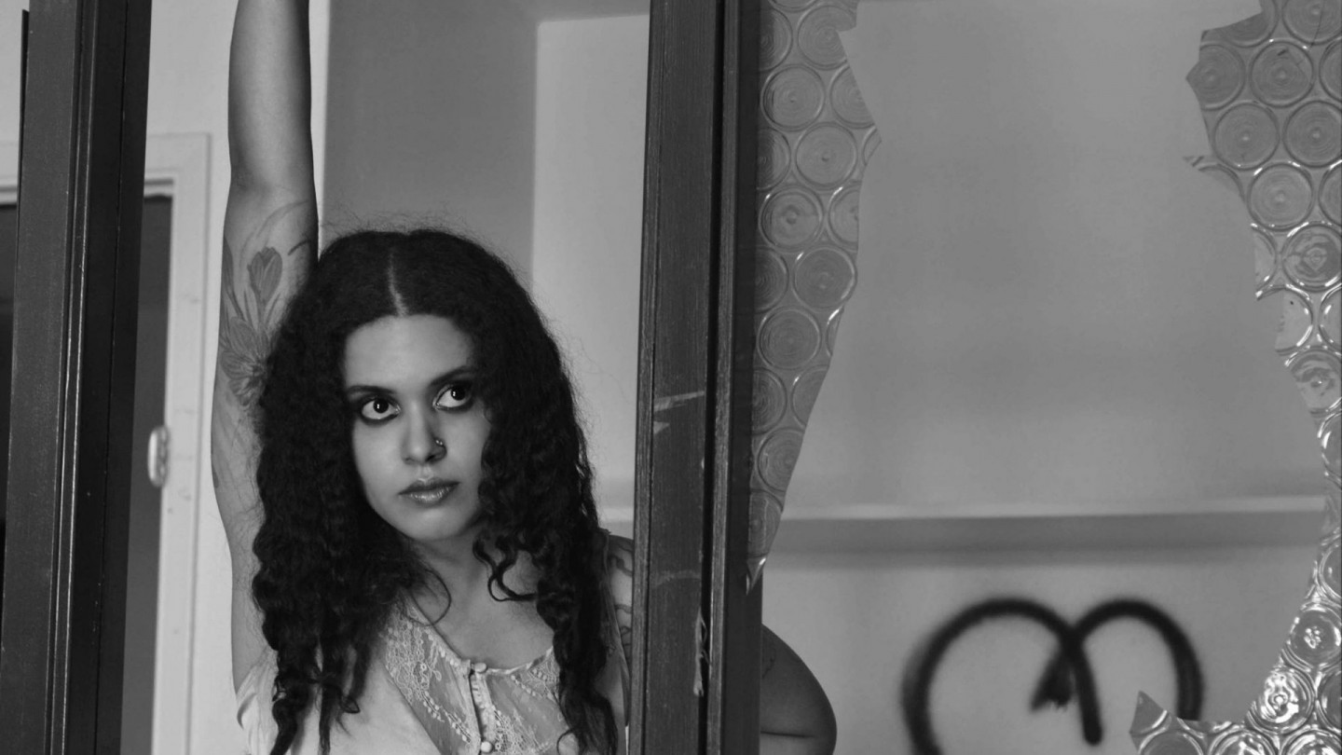

Meet Maryam Haddad
by Chris Twist
Maryam Haddad is one of my best friends in the world. She was there when I truly needed her to be there. Maryam Haddad and myself, Chris Twist, have been talking about music, mostly about our music, for about ten years. When we were still teenagers, we were in a band together. This band was called Chemical Ex, and I think that this was the first time in my life in which I liked working in a group. Chemical Ex made some fairly incredible and awe-inspiring music. I still believe that some of the best music that I have ever made was with Chemical Ex. Of course, the main character, with her voice and her admirable guitar skills, was Maryam Haddad. She made Chemical Ex everything that it was, and for that, I will always thank her.
Chemical Ex’s music was rock with 80’s-ish synths. I felt that in Las Vegas at the time, there wasn’t another band who sounded like our band. Here is one of our songs, and definitely my favorite song. In this song, I played the synthesizer:
So, we were a band a few years, but as we were getting older our lives changed, naturally. Eventually, our band was truly done. Some of us had to leave Las Vegas for new work. Maryam Haddad’s new music is called NightNight, and you will see why when you listen to the song in this article.
Why did Maryam Haddad finally make music that he wanted to give to the world again? After so many years, why does she finally feel like she could give us stunning and wonderful music again? Well, I gave Maryam Haddad three questions to learn more about who she is now and what she wants now.
Why, after many years, are you giving the world new music again?
I never stopped writing music. After Chemical Ex broke up, I moved to Seattle for a few years and tried to start a band up there. I met some amazing musicians and wrote some material that I liked, but never had the chance to record an album in full.
I’ve never had to luxury of being able to make music as my sole income, so the process takes more time. I was working in recording studios as an engineer, working at a music store in the day and also trying to write, produce and rehearse music.
The NightNight EP is the end of all those efforts. It is, what I feel to be, the best parts of everything I had written while leaving Las Vegas and living in Seattle.
If you had to tell a person about what kind of music your new music is, what would you say?
My new music is focused on telling stories of real events that have happened in my life. I tried to make the production and writing of the songs match the feeling of where I was when those events happened.
As far as genre, its a blend of rock, trip-hop, industrial and various other genres.
What do you want from this music?
I want to people to hear it and feel something. I’m the type of person who hears sad songs and feels better. I like hearing something that makes me feel less alone. I hope I can do that for someone else.
And if they dance or sing along, that never hurts anyone.
I do remember that Maryam Haddad loved goth music at least close to how much I love goth music and I definitely see that in this song. I also think about “dreamy music” when I am listening to this song and all of her album. If you, like me, love “dreamy music”, then this album will be an exceptional part of your playlist.
I do believe that her voice is an effective, potent, rich, and a little bit glowing. I guess that I am trying to say that her voice is even better than before, now that her voice is truly adult. I also believe that her lyrics are stronger as well.
As a person who listens to dreamy music each night before I am sleeping, all of these songs work very well to that end. I have been listening to all of these songs at the end of my day. For any of you who have problems sleeping, I think that listening to this album will help you. It differently helps me.
Here is the website for her band, “NightNight” – nightnight.org

